Affidavit of Attorney’s Name Certifying Regarding Rule 8.5 of the Montana Rules of Professional Conduct in Connection with Montana District Court

Pro Hac Vice Application
I, Attorney’s Name, being first duly sworn under oath, do hereby depose and say under penalty of perjury that if called to testify in a court of law, I would testify from my own personal knowledge as follows:
- I am an attorney admitted in (list states admitted here) who resides in (city, state) and I am not regularly employed in Montana.
- This certification is in connection with my pro hac vice admission in the United States District Court for the District of Montana in Case # (Case number and title here) on behalf of the (entity attorney is representing from).
- Pursuant to Rule 8.5 of the Montana Rules of Professional Conduct, I certify to the Supreme Cout of the State of Montana, and to the State Bar of Montana, that, except as to Rules 6.1 through 6.4, I will be bound by the Montana Rules of Professional Conduct in my practice of law in Montana in the above-referenced case and will be subject to the disciplinary authority of the State.

I swear under the penalty of perjury that the foregoing is true and correct to the best of my knowledge, information, and belief.

Dated this ____ day of _____, 2026.

Attorney’s printed name

Attorney’s signature

(Notarial Seal)
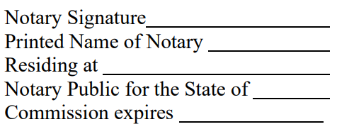

Subscribed and sworn to before me on ____________________

